**1. Define the Problem:**

Create a simple program that:

* Accepts a number as input.
* Checks if the number is even or odd.
* Displays "Even number" if the number is divisible by 2, otherwise "Odd number".

**2. Identify Key Processes:**

* Start the program
* Input a number
* Check if the number is divisible by 2
* If divisible, display "Even number"
* Else, display "Odd number"
* End the program

**3. Draw the Flowchart (Text Representation):**

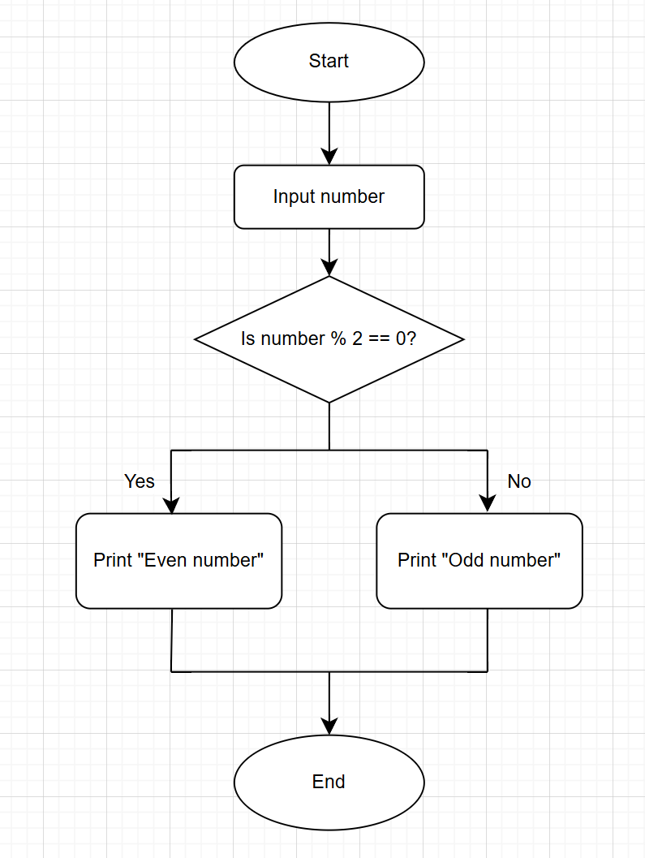

**4. Transition to Pseudocode:**

* **Start** → Start of the process
* **Input Number** → Prompt the user for input
* **Decision** → Use an if condition to check divisibility
* **Output** → Print the appropriate message
* **End** → End the process

**5. Pseudocode:**

Start

Prompt user to enter a number

Read number

If number modulo **2** **equals** **0** then

Print "Even number"

Else

Print "Odd number"

End If

End